
OPERATIONAL EXCELLENCE | STEP 2 OF THE STORE OPTIMIZATION PROJECT
Step 2 — AS-IS & TO-BE
Process Mapping
Factory Material Management
Current-state and proposed future-state processes, systems and record-keeping
Project | Store Optimization
Organization | Cosmos Air Distribution Products
Prepared by | Mahir Valani
Date | 20/05/2026
Document version | v0.1 — First draft for review
Status | Draft — proposals subject to ERP validation

Table of Contents
1. Executive Summary 3
2. Project Context and Scope 4
2.1 Context 4
2.2 Scope 4
2.3 Key terms 4
3. Process-Mapping Methodology 5
4. AS-IS Process Overview 6
4.1 Process stages 6
5. Detailed AS-IS Swimlane Map 7
6. Current Systems and Record-Keeping 8
7. Key Process Gaps and Potential Implications 9
8. TO-BE Process Overview 9
8.1 Proposed changes 9
8.2 Other TO-BE elements and their status 9
9. Detailed TO-BE Swimlane Map 11
10. AS-IS vs TO-BE Comparison 12
10.1 Detailed comparison 12
10.2 AS-IS vs TO-BE at a glance 13
10.3 Process gaps mapped to improvements 13
11. Proposed Changes: GRN and MIN in ERP 14
11.1 Change A — GRN in ERP 14
11.2 Change B — MIN in ERP 14
11.3 Elements subject to ERP feasibility 14
11.4 FIFO — scope note 14
12. ERP Dependencies and Validation Requirements 15
13. Expected Benefits and Implementation Considerations 15
13.1 Expected benefits 15
13.2 Implementation considerations 16
14. Recommended Next Steps 16
14.2 Information pending confirmation 16
Appendix A: Supporting Reference Maps 18

Headings use Word heading styles. Page numbers shown here are static — refresh them manually after editing, or insert an automatic table of contents via References › Table of Contents.

1. Executive Summary
This report documents the current-state (AS-IS) and proposed future-state (TO-BE) processes for Factory Material Management at a manufacturing facility. It is Step 2 of the Store Optimization Project, following the Gemba Walk and initial diagnostic study (Step 1). The next workstreams — FSN analysis, rack designing, binning, labeling, FIFO, kitting and Kanban — will be documented separately.

Current state
Material management currently relies on a combination of ERP, manual documentation and Excel-based tracking. The Sales Team creates the Job Card in ERP; the Store Manager determines the material requirement and issues an MRN (Material Requisition Note), which enters procurement through the Procure-to-Pay (P2P) cycle. When goods arrive, the GRN (Goods Received Note) is created manually and the material is placed in its storage area. Separately, Production creates an MRS (Material Requisition Slip) in ERP when material is needed for a job; the Stores Operator issues material, and the issue, extra material, remaining quantity, rates and returns are tracked manually in an Excel file kept on one PC and used by two storekeepers.

Key gaps (potential implications, not measured)
- GRN creation is manual.
- Material issue tracking is held in Excel even though the MRS is created in ERP.
- Returns and quantity adjustments are handled manually in Excel.
- The Excel file is maintained on one PC.
- There is no single integrated view of the described inward and outward transactions.

Proposed future state
The project owner has proposed two specific ERP changes:
(A) create the GRN in ERP after material receipt and physical verification, updating the inward stock record through the appropriate ERP transaction
(B) generate a MIN (Material Issue Note) in ERP after material is issued against the MRS, updating the outward stock record. Further elements — a system stock / ROP (Reorder Point) check, stock-visibility reporting and alerts — are described as proposed and remain subject to ERP feasibility and configuration validation.
Expected benefits. Better recording of receipts, better traceability of issues and less dependence on Excel for the transactions covered by the two changes — all subject to correct ERP configuration and use. These are expected benefits, not achieved outcomes; no measured savings are claimed.
Next step. Validate ERP capability and the open process details (Section 12), reconcile opening stock with existing Excel records, evaluate the returns process, and agree owners and dates (Section 14).

2. Project Context and Scope

2.1 Context
The Gemba Walk (Step 1) observed that material management in the stores relies on manual effort and that several structured practices were not evident. Step 2 records how the process actually runs today, who is responsible, which systems and records are used, where the process gaps lie, and what is proposed to change. It is written so that management can review it without a verbal explanation.

2.2 Scope
Dimension | In scope | Out of scope / not claimed
Process | Customer order to Job Card; MRN; goods receipt and storage; MRS; material issue; returns | Full Procure-to-Pay analysis (separate related workstream); ABC–XYZ, rack, binning, labeling, FIFO, kitting and Kanban design (separate documents)
Systems | ERP, manual GRN, Excel tracking, manual adjustments | ERP configuration or technical design; features not confirmed as available
Proposals | GRN in ERP; MIN in ERP; items marked “subject to ERP feasibility” | Measured savings, completed implementations, FIFO as an ERP feature
Table 1 — Scope of the process-mapping study

2.3 Key terms
Term | Meaning | Use in this report
ERP | Enterprise resource planning system used by the facility (system name: To be confirmed) | Current: Job Card, MRN, MRS. Proposed: GRN and MIN
Job Card | ERP record created by the Sales Team | Basis for determining the material requirement
MRN | Material Requisition Note | Issued by the Store Manager; goes to the Purchase Head and enters procurement
MRS | Material Requisition Slip | Created in ERP by Production when material is needed for a job; sent to Stores
GRN | Goods Received Note | Currently created manually on receipt; proposed to be created in ERP
MIN | Material Issue Note | Proposed ERP document generated after material is issued against an MRS
ROP | Reorder Point | Proposed stock check, subject to ERP capability
P2P | Procure-to-Pay | Separate related workstream; shown only as an interface
FIFO | First-In, First-Out | Not an ERP functionality; separate workstream
Table 2 — Abbreviations and terms
Do not confuse MRN with MRS
The MRN (Material Requisition Note) is raised by the Store Manager to request procurement. The MRS (Material Requisition Slip) is raised by Production to request material from Stores for a job. They are different documents with different owners.

3. Process-Mapping Methodology
The maps are based on the project owner’s written clarification of the process, which governs wherever it differs from a diagram. The two source process-map images (AS-IS and TO-BE) are referenced as supporting material and can be placed in Appendix B. No steps or functionality have been added beyond the written clarification. The maps use six swimlanes — Sales Team, Store Manager / Stores, Purchase Department, Supplier, Receiving / Stores and Production Team — in both the AS-IS and TO-BE views, so that the two can be compared directly.
To keep facts and proposals apart, statements in this report carry one of the following status labels.
Status label | Meaning
Current fact | Confirmed by the project owner for the current state
Proposed change | Proposed by the project owner; not yet implemented
Expected benefit | Anticipated result, subject to validation; not an achieved outcome
Pending validation | Detail not yet confirmed, or capability not yet verified in ERP
Table 3 — Status labels used in this report

4. AS-IS Process Overview
The current process runs as two linked flows. The first starts with the customer order and ends with material placed in storage. The second starts when Production needs material for a job and ends with returns adjusted in Excel. The flows run in parallel: Production may raise an MRS whenever material is needed, and availability in Stores determines whether it can be issued — Production does not wait for a new MRS until procurement completes.

4.1 Process stages
Stage | What happens | Responsible | System / record | Status
1 Customer order and Job Card | Sales Team receives the customer order and creates the Job Card in ERP; the Job Card is the basis for determining material requirement | Sales Team | ERP (Job Card) | Current fact
2 Material planning and MRN | Store Manager reviews the Job Card, determines the material requirement and issues an MRN to the Purchase Head | Store Manager | ERP (MRN) | Current fact
3 Procurement interface | MRN enters procurement through the Procure-to-Pay cycle; procured material subsequently arrives at the factory. P2P is documented separately | Purchase Department; Supplier | P2P (separate workstream) | Current fact; detail out of scope
4 Goods receipt and storage | Goods arrive; the GRN is created manually; material is placed in its respective storage area | Receiving / Stores (person: To be confirmed) | Manual GRN | Current fact
5 Production requisition | When material is needed for a job, Production creates an MRS in ERP, which is sent to Stores | Production Team | ERP (MRS) | Current fact
6 Material issue | Stores Operator checks the MRS and issues material to Production; the issue is recorded manually in Excel (quantity issued, extra material, remaining quantity, rates, returns) — not through a fully ERP-generated MIN | Stores Operator; two storekeepers | Excel on one PC | Current fact
7 Material returns | A 15-day return policy applies to unused material issued to Production; returns are tracked in the same Excel process and the storekeeper manually adjusts quantities | Production Team; storekeeper | Excel; manual adjustment | Current fact; approval, documentation and exceptions pending validation
Table 4 — AS-IS process stages
Pending validation — AS-IS details
The exact approval process, return documentation and policy exceptions have not been confirmed. Also unconfirmed: who performs physical verification at receipt, the person who creates the GRN, and the ERP system name. These are listed in Section 14.2 and are not assumed here.

5. Detailed AS-IS Swimlane Map
Figure 1 shows the current process as understood from the project owner’s clarification. Solid arrows show process flow; dashed arrows show information or document flow. Amber steps are manual or Excel-based; the Procure-to-Pay cycle is an interface only.
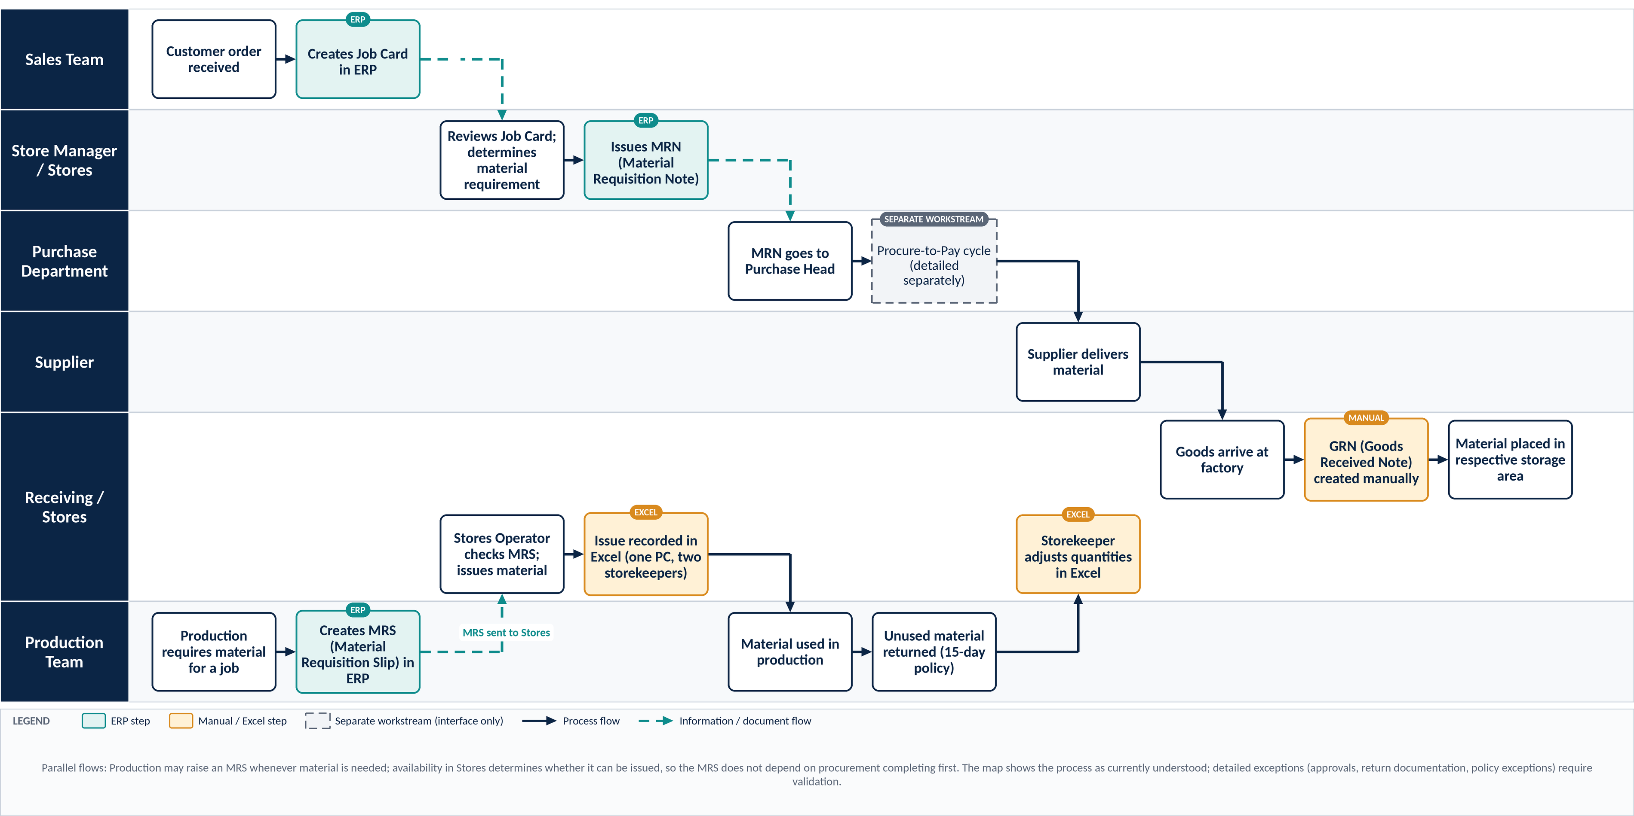
Figure 1 — AS-IS swimlane map — Factory Material Management (embedded high-resolution graphic)

6. Current Systems and Record-Keeping
Material management relies on a combination of ERP, manual documentation and Excel-based tracking. The matrix below sets out how each system or method is used today.
System / method | Current use | Used by (as described)
ERP | Job Card, MRN, MRS and other existing ERP activities as shown in the source material | Sales Team; Store Manager; Production Team
Manual GRN process | Goods receipt documentation is created manually | Receiving / Stores (person: To be confirmed)
Excel | Material issue tracking: quantities, extra issues, remaining quantities, rates and returns. One file on one PC | Two storekeepers
Manual adjustment | Storekeeper updates Excel quantities for relevant transactions and returns | Storekeeper
Table 5 — System-responsibility matrix (AS-IS)
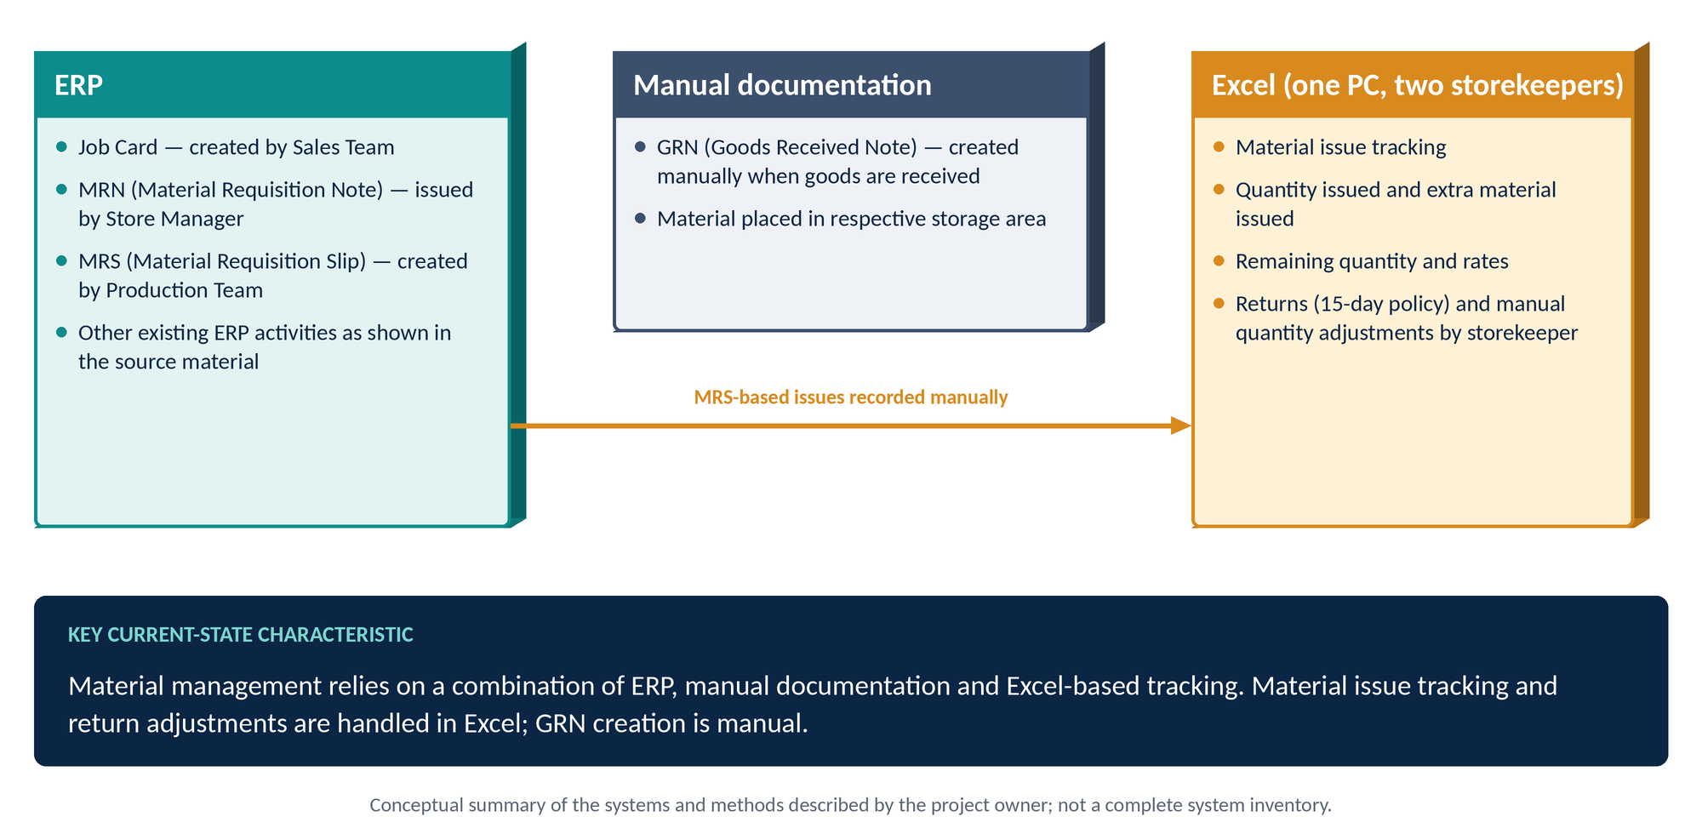
Figure 2 — ERP, manual documentation and Excel — current system landscape
Reading this matrix correctly
This report does not claim that every inventory transaction sits outside ERP. It records specifically that material issue tracking and return adjustments, as described by the project owner, are handled in Excel, and that the GRN is created manually.

7. Key Process Gaps and Potential Implications
Only gaps supported by the supplied project information are listed. The implications are potential implications; none has been measured or verified, and no error rate, delay, loss or saving is quantified.
Gap | Basis (supplied information) | Potential operational implication | Validation required
G-1 | GRN is created manually | Duplicate effort; delayed visibility of receipts; risk of inconsistent records | How receipts are currently reflected in stock records
G-2 | Issue tracking is in Excel although the MRS is created in ERP | Issue information held in two places; possible duplicate effort and inconsistency between ERP and Excel | Whether and how ERP MRS data and Excel entries are compared today
G-3 | Returns are tracked in Excel with manual quantity adjustment | Risk of adjustment errors and inconsistent balances | Return documentation, approvals and exceptions (pending)
G-4 | Excel file is maintained on one PC and used by two storekeepers | Dependence on a single file and location; potential access, version or continuity risk | Backup and access arrangements (not confirmed)
G-5 | Inward (manual GRN) and outward (Excel) transactions sit in different places | No single integrated view of the described transactions; slower or less reliable stock visibility | Which stock reports exist and what they draw from
Table 6 — Process gaps and potential implications (not measured)

8. TO-BE Process Overview
The TO-BE view keeps the same departmental lanes and makes two specific changes proposed by the project owner. It adds no further process steps beyond the clarification; elements that depend on ERP capability are labelled as proposed.

8.1 Proposed changes
Change | Proposed process | Status
A — GRN in ERP | After material receipt and physical verification, create the GRN in ERP and update the inward stock record through the appropriate ERP transaction | Proposed change
B — MIN in ERP | Production creates the MRS in ERP; Stores issues material against it; a MIN is then generated in ERP and the outward stock record is updated through the appropriate ERP transaction | Proposed change
Table 7 — The two proposed ERP changes

8.2 Other TO-BE elements and their status
TO-BE element | Description | Status
System stock / ROP check | Stock check after the requirement is determined, before an MRN is raised | Proposed — subject to ERP feasibility / configuration
MRN in ERP where procurement is required | Existing MRN step; also the route when material is unavailable at issue | Existing ERP step
Procure-to-Pay interface | Referenced only; detailed P2P is a separate workstream | Separate workstream
Stores checks availability | Before issue; if unavailable, the MRN / procurement route applies | Proposed process step
Updated stock visibility | Visibility of updated stock from ERP transactions | Proposed — subject to ERP capability
Material returns | 15-day policy and recording method to be evaluated separately; no ERP return process is assumed | Pending evaluation
Table 8 — Status of TO-BE elements

9. Detailed TO-BE Swimlane Map
Figure 3 shows the proposed process using the same lanes as the AS-IS map. Teal-filled steps are the two proposed ERP changes; dashed steps are proposed and subject to ERP feasibility or configuration. Where material is unavailable, the MRN / procurement route applies.
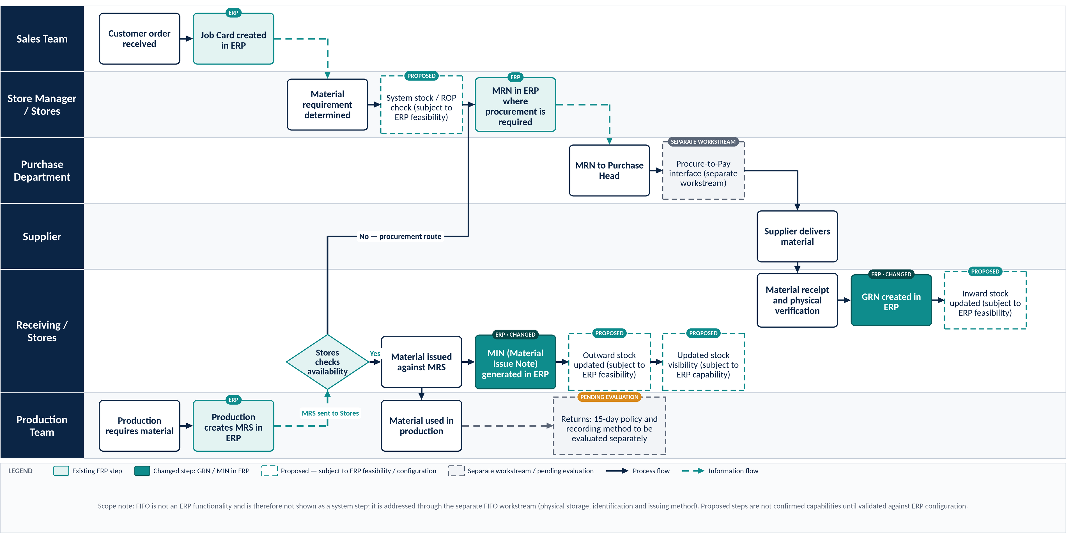
Figure 3 — TO-BE swimlane map — Factory Material Management (embedded high-resolution graphic)

10. AS-IS vs TO-BE Comparison

10.1 Detailed comparison
Process area | AS-IS | TO-BE proposal | Expected improvement | Dependencies / validation required
Goods receipt documentation | GRN created manually after goods arrive | GRN created in ERP after receipt and physical verification | Expected: receipt documented in the system of record | ERP GRN transaction available and configured; roles and format
Inward stock recording | Material placed in storage; a manual GRN records receipt | Inward stock record updated through the appropriate ERP transaction after the GRN | Expected: inward quantities captured consistently | Whether GRN updates stock balances; opening-stock reconciliation
Production requisition | Production creates the MRS in ERP and sends it to Stores | No change proposed: Production creates the MRS in ERP | Continuity; MRS becomes the basis for the MIN | Linkage between MRS and MIN in ERP
Material issue recording | Stores Operator checks the MRS and issues; issue recorded manually in Excel (quantity, extra material, remaining quantity, rates) | Stores checks availability, issues against the MRS, then generates a MIN in ERP | Expected: better traceability; reduced reliance on Excel for issue tracking | MIN availability; handling of extra issues and rates in ERP
Outward stock recording | Outward position reflected in Excel remaining quantities | Outward stock record updated through the appropriate ERP transaction after the MIN | Expected: outward movements recorded consistently | Stock-balance update capability; user discipline
Material returns | 15-day policy for unused material; tracked in Excel with manual adjustment by the storekeeper | No confirmed ERP return process. The 15-day policy and return-recording method to be evaluated separately for integration or control improvements | To be determined after evaluation | Return documentation, approvals and exceptions (pending); ERP return capability
Inventory visibility | No single integrated view of the described inward and outward transactions | Improved potential for visibility from ERP transactions and reports | Expected potential; not presented as real-time until verified | Available stock reports; timing of stock updates
Excel dependency | Issue tracking, extra issues, remaining quantities, rates and returns in Excel on one PC | Reduced for the transactions covered by the GRN and MIN changes; Excel use for returns remains until evaluated | Expected reduction for covered transactions only | Reconciliation approach; what Excel data remains
Reporting and control | Reporting not confirmed; information spread across ERP, manual GRN and Excel | Reporting from ERP transactions; ROP check and alerts proposed | Expected: better control potential | Reports available; ROP / alert configuration
Table 9 — Detailed AS-IS vs TO-BE comparison

10.2 AS-IS vs TO-BE at a glance
AS-IS |  | TO-BE (proposed)
GRN created manually | ➔ | GRN created in ERP after physical verification
Inward quantities depend on manual GRN | ➔ | Inward stock updated via ERP transaction (subject to validation)
MRS in ERP; issue recorded in Excel | ➔ | MRS in ERP; MIN generated in ERP after issue
Outward position held in Excel | ➔ | Outward stock updated via ERP transaction (subject to validation)
Returns adjusted manually in Excel | ➔ | Return process to be evaluated separately
Figure 4 — Comparison of key process areas (editable Word table)

10.3 Process gaps mapped to improvements
Gap | Proposed improvement | Addressed by | Status
G-1 | Create the GRN in ERP after physical verification | Change A — GRN in ERP | Proposed change
G-2 | Generate a MIN in ERP after issue against the MRS | Change B — MIN in ERP | Proposed change
G-3 | Evaluate return recording and the 15-day policy for integration or control improvements | Separate evaluation | Pending evaluation
G-4 | Reduce reliance on the single-PC Excel file for covered transactions; decide arrangements for Excel use that remains | Changes A and B; evaluation of returns | Proposed / pending
G-5 | Record inward and outward transactions in ERP; report from them | Changes A and B; reporting validation | Subject to ERP feasibility
Table 10 — Gap-to-improvement mapping

11. Proposed Changes: GRN and MIN in ERP

11.1 Change A — GRN in ERP
Element | Proposal
Trigger | Material has been received and physically verified
Action | Create the GRN in ERP
System effect | Update the inward stock record through the appropriate ERP transaction
Replaces | The manual GRN creation described for the current state
To be defined | ERP transaction name; who creates the GRN; verification step and controls; document format; handling of discrepancies
Table 11 — Change A — GRN in ERP

11.2 Change B — MIN in ERP
Element | Proposal
Trigger | Production has created the MRS in ERP and Stores has checked availability
Action | Stores issues material against the MRS; a MIN is generated in ERP after issue
System effect | Update the outward stock record through the appropriate ERP transaction
Replaces | Reliance on manual Excel tracking for material issue, for the transactions covered
Where material is unavailable | The MRN / procurement route applies
To be defined | Handling of extra material issued and rates; link between MRS and MIN; role of the Stores Operator and storekeepers
Table 12 — Change B — MIN in ERP

11.3 Elements subject to ERP feasibility
The following are described as proposed and must be validated before being treated as capabilities: the system stock / ROP check; updating stock balances from the GRN and MIN transactions; stock reports and visibility; and any alerts. No real-time dashboard, automated notification or other feature is assumed to exist.

12. ERP Dependencies and Validation Requirements
The proposals depend on ERP capability and on the practicalities of transition. The checklist below should be completed before implementation is planned.
No. | Validation item | Why it matters | Status
V-1 | Does ERP support GRN creation and inward stock updates? | Change A depends on it | Open
V-2 | Does ERP support MIN generation after material issue? | Change B depends on it | Open
V-3 | Can ERP update stock balances from these transactions? | Needed for inward and outward records | Open
V-4 | How will opening stock and existing Excel records be reconciled? | Avoids inconsistent starting balances | Open
V-5 | How will material returns be recorded and controlled (15-day policy)? | No ERP return process is assumed | Open
V-6 | What stock reports are available? | Determines achievable visibility and reporting | Open
V-7 | Are ROP checks or low-stock alerts available, or do they need configuration? | Proposed step is not assumed to exist | Open
V-8 | What training and procedural changes are required? | Roles of Stores Operator, storekeepers and Production | Open
Table 13 — ERP validation checklist

13. Expected Benefits and Implementation Considerations

13.1 Expected benefits
Expected benefit | Linked change | Condition
Better recording of material receipts | Change A | Correct ERP configuration and consistent use
Better traceability of material issues | Change B | MIN generated against each issue
Reduced dependence on Excel for the covered transactions | Changes A and B | Excel remains for returns until evaluated
Improved consistency between recorded inward and outward transactions | Changes A and B | Reconciled opening stock; disciplined use
Better potential for stock visibility and reporting | Changes A and B | Reports and stock updates validated in ERP
Table 14 — Expected benefits (not achieved outcomes)
These are expected benefits only. No measured savings, time reductions or accuracy figures are claimed.

13.2 Implementation considerations
- Reconcile opening stock with existing Excel records before the ERP transactions become the record of stock.
- Define who creates the GRN and MIN, and how physical verification is evidenced.
- Decide how Excel will be used, and when it will be retired, for the transactions covered.
- Evaluate the 15-day return policy and the return-recording method separately.
- Plan training and procedural changes for Receiving / Stores, storekeepers and Production.
- Keep FIFO improvement within its own workstream; do not treat the ERP changes as delivering it.

14. Recommended Next Steps
The steps below are recommendations; none has been performed as part of this draft.
- Confirm with the ERP team which GRN, MIN, stock-update, ROP and reporting capabilities are available (Section 12).
- Close the open AS-IS details: approval process, return documentation, policy exceptions and receipt verification.
- Reconcile opening stock with the existing Excel records.
- Evaluate the returns process and the 15-day policy.
- Define the GRN and MIN procedure, roles and controls.
- Assign accountable owners and target dates; agree how implementation status will be reviewed.
- Proceed to the Step 3 workstreams (ABC–XYZ, rack designing, binning, labeling, FIFO, kitting, Kanban), with FIFO handled as a separate operational workstream.

Appendix A: Supporting Reference Maps
The two source process-map images may be inserted here as reference visuals. They were not embedded in this draft.
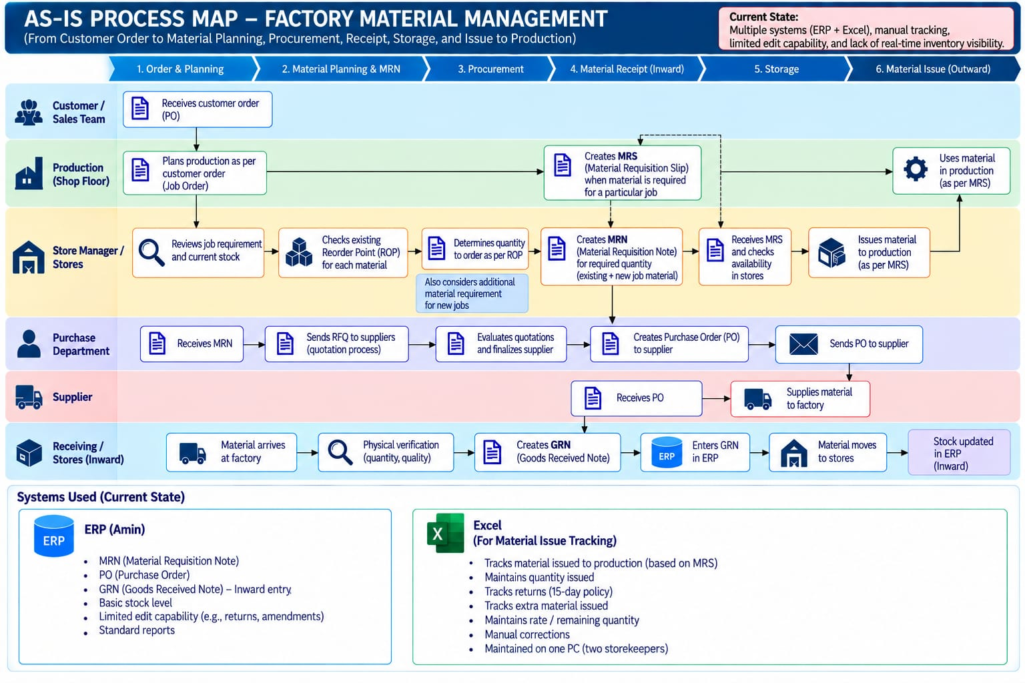 [ Insert Source
Figure 5 — Reference placeholder — Source AS-IS Process Map — Factory Material Management
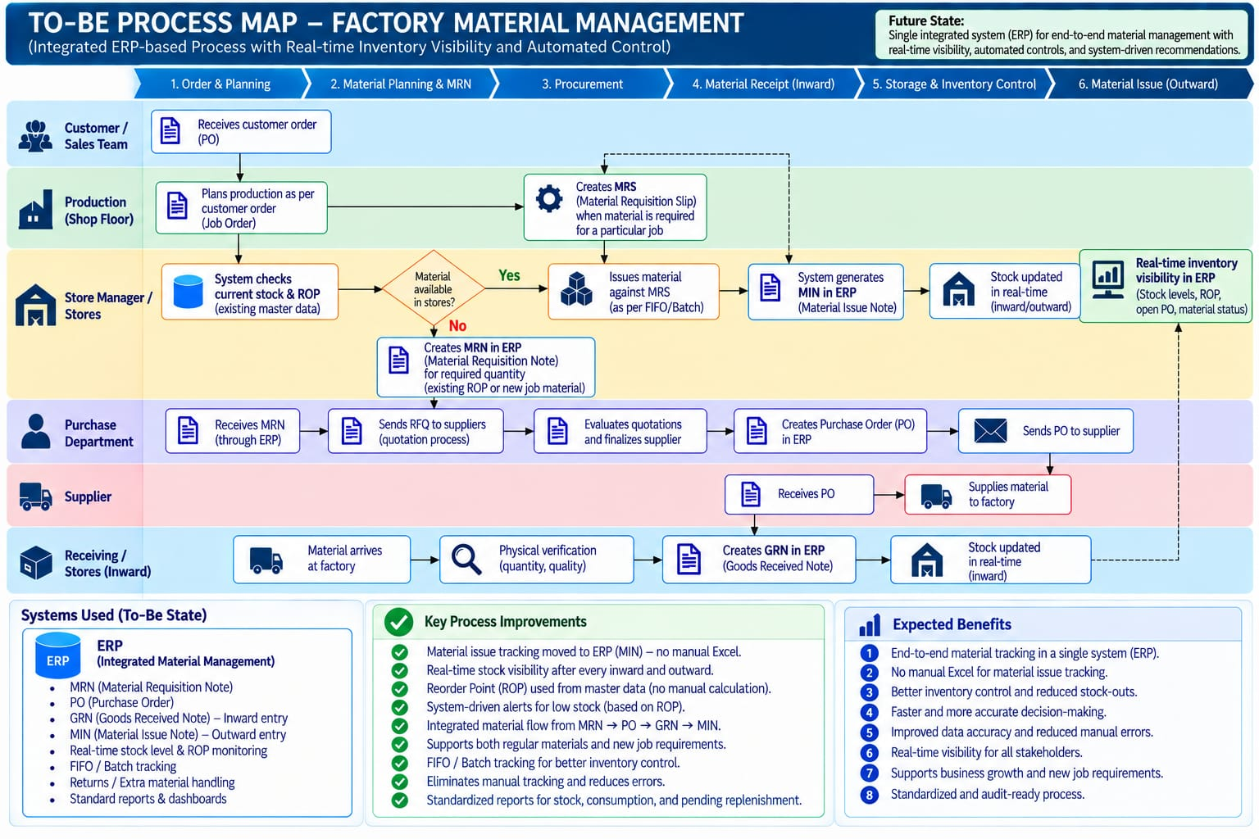
Figure 6 — Reference placeholder — Source TO-BE Process Map — Factory Material Management

